November 7, 2007

Dear Pharmacist:

Ther-Rx Corporation is pleased to announce as of October 1, 2007, PreCare Premier™ has been added to preferred status on Illinois Medicaid and Illinois Cares Rx Plus. PreCare Premier, a prescription prenatal vitamin, has many advantages that can be beneficial for your patients.

PreCare Premier is a part of the #1 line of prenatal vitamins offered by Ther-Rx.¹ PreCare Premier is a small, easy-to-swallow, once daily caplet that contains 50 mg of docusate sodium (stool softener) to help reduce constipation.²⁻³ PreCare Premier contains 1mg folic acid to help reduce the risk of NTDs.⁴ PreCare Premier contains high levels of B₆ to help relieve the symptoms of morning sickness and 30 mg of iron, the amount recommended by the CDC.⁵⁻⁶ In addition, we have added 250 mg of calcium to support bone health for both mom and baby.⁷

We hope you recommend PreCare Premier for your pregnant and nursing patients. PreCare Premier is a name you and your patients can trust.

For more information, please see the enclosed prescribing information, call us at 877-567-7676, or visit us at www.precarepremier.com.

Sincerely,

James A. Anderson
Vice President, Managed Health Care & Trade
Ther-Rx Corporation

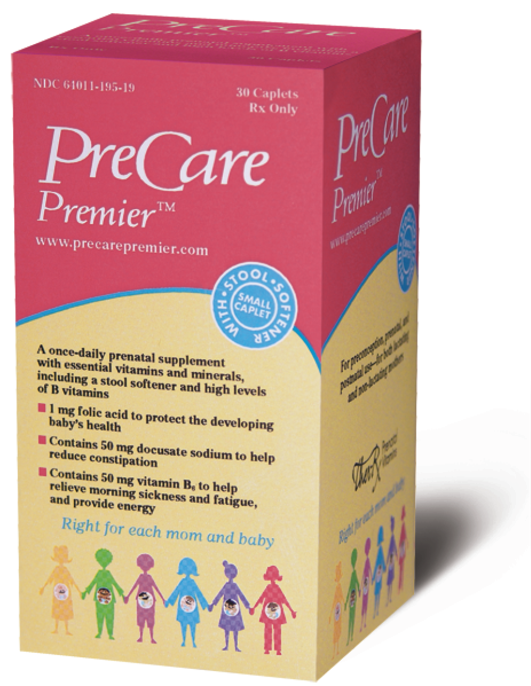

Marketed by Ther-Rx Corporation, St. Louis, MO 63044
© 2007 Ther-Rx Corporation 04-430 11/07

